The Effects of Mutations in Genes LEA5 and RD22 on Populus tremuloides
Fatality During Sudden Aspen Decline
Isaac C. Fry
Mentor: Viva J. Rasé
Frontiers of Science Institute 2018
University of Northern Colorado

ABSTRACT

Populus tremuloides (Quaking Aspens) are a widely distributed, deciduous tree found across Western forests. Aspens have the ability to asexually reproduce through cloning suckers when under stress, meaning one organism may produce multiple trees; therefore, an entire forest may only be composed of a few organisms with low genetic diversity. Sudden Aspen Decline (SAD) is the widespread and landscape-scale mortality of aspens in the Southwestern United States, affecting seventeen percent of the aspens found in Colorado. Stands affected by SAD experience significant branch dieback, overstory decrease, and a failure to reproduce through suckers. SAD has a strong connection to drought, and this study researches the possible mutations in the drought resistance genes LEA5 and RD22 of fatally affected aspens. Samples were collected from Medicine Bow National Forest, and Polymerase Chain Reaction (PCR) was run on these samples using LEA5 and RD22 primers. Gel electrophoresis produced results indicative of PCR failure, therefore creating inconclusive results. Expected results would be a mutation found in a drought resistance gene of the fatally affected aspens with dead and living populations demonstrating a high level of population similarity.

INTRODUCTION

Seventeen percent of the Quaking Aspens (species Populus tremuloides), characterized visually by their white poplar bark with black markings and leaves that tremble in the wind, have seen rapid dieback and mortality since 2008 (Forest Service, United States of America). As the aspen used to be the most distributed tree across North America (Howard, 1996), the decline, deemed Sudden Aspen Decline (SAD), has caused concern across environmental and scientific communities. The decline has been documented throughout a majority of the Rocky Mountains from Colorado to Arizona and into Wyoming and has been theorized to be caused by extreme drought (Worrall, 2010). Further research into the genetic reasons of SAD would equip ecologists and environmentalists to deal with similar diseases in the future and provide support to the currently affected stands.
Populus tremuloides ranges from the majority of the continental United States up to Canada and into Alaska (Forest Service). Like most poplar trees, which come from the same genus, aspens tend to act as pioneer species, venturing into plots of land uninhabited by other plant species and distributing rapidly and efficiently (Possen et al., 2011). Aspen trees have the ability to reproduce sexually through catkins, flowers that hang linearly and release fine seeds. Catkins produce seeds in a high quantity, but they have trouble taking root and growing, especially in arid climates such as Colorado (Mitton, 1980). However, in unfavorable conditions, like arid climates, aspen trees can reproduce asexually through cloning, providing the opportunity to flourish in multiple environmental conditions.
All Quaking Aspens have extensive lateral root systems which allow them to develop clones. During asexual reproduction, suckers, offshoots from the lateral roots of aspens, will sprout on the surface and develop into a new tree, but not by any means into a new organism. Since two seeds did not germinate, the new aspen growth has the same genome as the tree it sprouted from. Aspens will continue this cycle of sprouting off other aspen roots through multiple iterations; the new tree can be individually recognized as a ramet but belongs to the system of one genetically consistent organism, called a genet, or clonal community (Cook, 1983). With this method of reproduction, a randomly selected portion of an aspen forest will most likely not follow the accepted definition of a population (a group of one species containing multiple genetically diverse individuals with the potential to interbreed by a select geographical area): they have the collective identity of one or a few organisms with little to no genetic diversity (Freeland, Kirk, & Peterson, 2013). An extreme example of this would be Pando, one aspen organism covering 43 hectares (Dewoody, Rowe, Hipkins, & Mock, 2008). Normally, seeds from two distinct parents will germinate with each other, crossing genetic material to create a genetically distinct zygote that will grow into an organism with a different combination of alleles. When reproducing through clones, stands, or a specific area of aspens, have slower rates of adaptation because no new genes or adaptations are introduced, as would happen in sexually reproducing populations. Since aspens reproduce asexually, what may appear as a forest of aspens may only contain a few genetically diverse organisms (Becheler, 2010). If no genetic material is being introduced, the only adaptations that happen are through chance mutations, which therefore makes aspens ill-equipped to deal with sudden, threatening environmental changes.
On the other hand, rapid reproduction through cloning comes with the ability to pioneer into new areas and the capacity for short-term spatial dominance. While it takes other species time to move into a new area by the spreading of seeds, aspens can quickly extend roots and develop suckers (Bresinsky, Körner, Kadereit, Neuhaus, & Sonnewald). Suckers can develop into one meter tall aspens in their first year, and proliferate a system of two meter lateral roots by their second (Cook, 1983). However, aspens do not flourish in overly shady areas, so they cannot effectively impose themselves into areas with mature overstory (the leafy canopy trees make). This means that aspens will not grow indefinitely, as new suckers forming under mature, leafy trees will receive too much shade (Worrall et al., 2010). Conifers will use this to their advantage and overpower mature aspen forests within 100-200 years. Since aspens can’t grow in shady areas, they can’t dominate an area already occupied with conifers; however, conifers can develop in shade and start a population in an area currently covered with aspens. An equilibrium exists between conifers that causes a general decline in aspen forests as it succeeds to a conifer forest. Natural wildfires can maintain this equilibrium and balance between the two competing species. Since aspens are pioneers and have a means for spatial domination, they can propagate into uncolonized areas, such as swathes of forest that have been burned, and prepare the area for further forestation. Furthermore, when a wildfire runs through a mountainside, aspen roots will survive the fire, meaning they can immediately start the development of suckers while conifers must wait for its gymnosporia, or pinecone, to grow; this allows aspens to spatially dominate a forest again (Forest Service).
Decades ago, scientists began noting a gradual decline in aspen as conifers began to march their way across what are now former aspen forests. The gradual decline affected stands of aspens and fragmented them into further, smaller stands, totaling for a twenty-four percent decline over 48 years (Orio, Callas, & Schaefer, 2005). Researchers predicted that new federal regulations governing wildfire prevention kept the natural equilibrium between aspens and conifers from being maintained (Forest Service). Starting in 2004, and potentially ending around 2009, researchers recorded a more rapid and steep decline in aspen populations, otherwise known as Sudden Aspen Decline. Aspens surveyed saw significant branch dieback, a failure to produce suckers, and decrease in overstory coverage (Worrall et al, 2008). SAD affected aspen forests on a landscape scale, spreading with such speed that aspens seemed to disappear with no sign of conifer overtaking. The disease seemed to have no effect on some aspens, leaving mosaic patches of survivors surrounded by the still remains of a previously quaking forest. The aspens suffering from SAD have failed to regenerate their leaves annually, ruling out dormancy or hibernation.
As a result of SAD, mountainsides previously flourishing with golden aspens in autumn have given way to faces predominantly covered by green conifers, demonstrating that the natural equilibrium has been thrown out of balance. This type of drastic change affects ecosystem health for forest habitats as aspens will cover a massive area. Furthermore, aspens provide large foraging areas for grazing animals, such as deer and elk, and their suckers also support a wide variety of animals (William Homme, 1995). Colorado’s tourism industry also relies on the leaves of aspens turning yellow in the fall, when sightseers flock to mountain communities for sightseeing. The biomass loss from the receding roots makes the soil more prone to erosion, which could lead to an increase in the already common landslides seen throughout the Rocky Mountains. Most importantly, though, is the possibility that the cause of the decline could spread to other species.
However, the definitive reason for this sudden decline remains unproven. SAD, as a whole, comes from a cascade of unwanted environmental conditions and stresses (Korb, Bombaci, & Siegel, 2014). Some believe that the sudden increase in mortality comes from pathogenic invasions, such as insects or fungus, backed by evidence such as mountain pines suffering from the invasion of the emerald pine beetle (Kristen A. Pelz, 2013) and that aspens have been found with fungal and larval infections (Worrall et al, 2008). While both ideas have valid aspects, drought seems to have a greater overall correlation to SAD. Drought acts as the main driver for SAD by lowering the ability for an aspen to resist invasions (such as fungus or insects), which is backed by field and laboratory research (Possen, 2011; Worrall, 2010; Ting Lan, 2012). Areas affected by SAD have also been affected by severe to extreme droughts (National Centers for Environmental Information, 2014), such as a drought in 2002, which catalyzed SAD in the Rocky Mountains. These droughts come with low precipitation and high temperatures, creating a situation in which aspens struggle to maintain water. Without water, aspens lose the ability to maintain turgor pressure (the water pressure inside individual cells which acts as an indicator of plant health), perform photosynthesis, and resist invasion, which leads to their untimely death (Kroeger, Zerzour, & Geimann, 2011).
While research has been conducted on the significance of SAD and the areas affected by it, the reason these environmental hazards create such a rapid decline in aspens is still relatively unknown. Normally, drought would cause blanket deterioration without selectivity to individuals or create mosaic patterns; SAD, on the other hand, creates patches and fragmentations of marked death, leading to the possible causation of a genetic disorder or disease. As Cook (1983) noted, cloning species will see “sharp differences in genetic identities over short distances” when coupled with strong selection such as surviving in the arid and drought-prone region of the Rocky Mountains. This provides a strong argument that even aspens close in proximity to each other would have genetic differences distinct enough for SAD to affect only certain genomes, creating the mosaic pattern studied. If aspens had a distinct mutation that SAD preyed on, then it would most likely be in the drought resistance genes. Aspens have genes that allow them survive droughts, water deficit stress, and desiccation (the loss of water from a plant). Examples include LEA (Late Embryogenesis Abundant) genes (Ting Lan, 2012), which aim to protect macromolecules during water stress. Another example includes RD (Resistance to Drought) genes (Yamaguchi and Shinozaki, 1993), which react to the release of Abscisic Acid that closes stomatal pores, therefore conserving water. This paper studies LEA5 and RD22, as chosen per the study conducted by Boy Possen and his team (2011) despite results saying that they didn’t respond to drought. However, their experiments were done on aspen specimens from Finland, where the environmental stresses are not the same as in the Rocky Mountains. The Finnish aspens have adapted differently to their environment, and therefore have a vastly different genotype when compared to aspens adapted to the dry and arid climate in the Southwestern United States. We seek to improve the knowledge and understanding of these genes when directly linked to drought-inflicted Sudden Aspen Decline in the Rocky Mountains.
An effective indicator of mutation, and therefore possible population diversity, are microsatellites. Otherwise known as simple sequence repeats, microsatellite DNA contains repeating base pair sequences, (i.e. CATCATCATCATCATCAT or GCAGCAGCAGCAGCA). These molecular markers mutate at an extremely fast rate (2.4 X 10 ⁻⁴; Thuillet et al, 2002) compared to normal DNA (10 ⁻⁹; Li, 1997), though the rate of mutation may differ even within a species (Bulut et al, 2009). The mutations found in microsatellites come in part from slipped strand mispairing, when the loss or gain of a repeated segment (such as one CAT in the first example), though multiple repeats may be added or deleted in a single mutation iteration. Since these variations occur at such a high rate, they can be used to determine the possibility of two populations’ likelihoods of diverging from each other in an adaptive pathway. (Freeland, J. R., Kirk, H., & Peterson, S. D., 2013). If SAD were to have a genetic component and stands fatally by SAD affected have two distinctly different microsatellites compared to stands non-fatally affected by SAD, the mutations might infer that the stands had diverged from each other in some manner. From studies done soon after the samples used in this study were collected, we know that the stands collected from were composed of multiple genetically distinct individuals. However, those studies did not show the likeliness or probability between the two populations. If microsatellite data is used, direct connection to the genes being expressed will not be apparent in this type of study as the microsatellites are a non-coding DNA region.
The spread of SAD ceased in 2009, but the stands affected by it have failed to regenerate (Worrall, Keck, & Marchetti, 2015). The fact that the dead stands failed to recover also supports the possible causation being a genetic disease, and drought triggered a reaction in a faulty gene that constituted for total organism degeneration. While the urgency of the issue has passed, and research has given way to post-disease studies, the results of this study can still be used to prepare and advise areas that may be prone to SAD or diseases like it. Furthermore, sudden diseases like this have multiple possible causes, though none of them were undeniably confirmed. The results of this study could also extend beyond aspens and into general cloning species, forest species, and organisms reliant upon environmental factors. Do diseases like this occur in isolated populations with no means of effectively diversifying offspring? Do all cloning species strictly adapt to their environment with little chance of further adaptation?
The aspen trees killed by SAD in the United States could have adapted in multiple ways. The deceased aspens may have acquired a chance mutation in their drought resistance genes, which would coincide with only a minority seventeen percent in overstory decrease. The dead aspen trees could have followed the main branch of the adaptive pathway, and the alive specimen could have a mutation or adaptation that kept them from dying. Finally, it could also be that all aspen trees have the same genome regarding drought resistance, and SAD affects populations without specificity to drought resistance genes. The mutation that causes SAD may be found in another area of the genomes of fatally affected aspens that this experiment will not study. We hypothesize, however, that the results will correlate with the former: the aspen trees affected fatally by SAD have a random, non-synonymous mutation compared to the aspen trees non-fatally affected. We test this theory by running samples through Polymerase Chain Reaction to isolate sequences from LEA5 and RD22, and then compare the sequencing information between the dead and living aspens. If the data from LEA5 and RD22 produces no conclusive results, then microsatellite data may also be used to study population divergence and the probability of mutation between dead and living stands.
The purposes of this study for further Populus tremuloides management are as follows: to analyze and investigate differences in LEA5 and RD22 in both dead and living samples of Populus tremuloides from the Rocky Mountains; to determine if Sudden Aspen Decline has little or no effect on aspens with a specific genotypic identity; and to determine the role of environmental factors on cloning populations. From these results, ecologists and biologists will be able to determine a course of action by which to prevent and manage SAD, or like diseases, in the future.

METHODS AND MATERIALS

1.1 Detailing of sample information
Due to logistical limitations, fresh samples could not be collected in the duration of this project. Instead, samples collected by Tyler Kinn in Medicine Bow National Forest, Laramie, Wyoming on the July 15th, 2017 were used (See Fig. 1). The aspen trees had the correct signs overstory dieback, and the aspens chosen came from two stands affected by the disease, referred to as North and South (also Dry and Wet). Samples from both deceased and healthy and mature and juvenile (suckers) aspens were chosen to ensure a broad range of data. The aspens chosen were spaced 100 meters apart from each other to assume genetic diversity. 24 total distinct samples were collected in all.
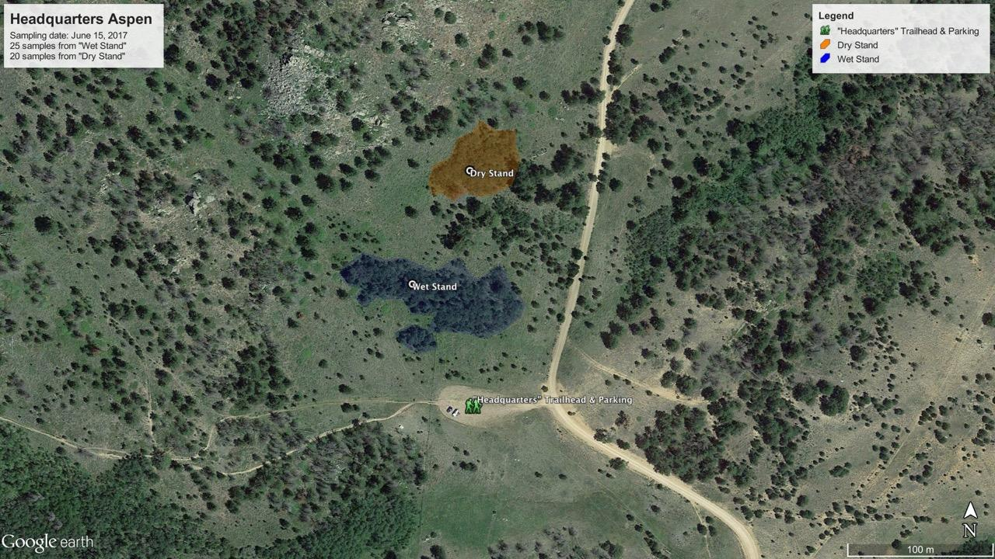(Fig. 1: Map of sample collection site in Medicine Bow National Forest, Laramie, WY)
Upon return to UNC, DNA was extracted from the Populus tremuloides tissue samples using QIAGEN DNeasy kit (Qiagen, Valencia, CA, USA). Tissue was finely ground prior to QIAGEN DNeasy kit use. The procedure was modified to elute the DNA twice instead of once. The DNA samples obtained from the kit were stored in separate Eppendorf tubes and marked with the stand, directionality (North or South), age, and condition (dead or living) of the sample the genetic material came from. The tubes were then moved to a freezer set at -80° Celsius for approximately one year, with little direct disturbance to the samples.
To isolate target sequences of DNA, Polymerase Chain Reaction (PCR) was used. Based on the study done by Possen (2011), the genes LEA5 and RD22 were chosen for this study. Using the National Center for Biotechnology Information (NCBI) Database, sequence information for these genes was found from the NCBI Primer Blast. The RD22 primers were based off of Arabidopsis thaliana (a weed) and the LEA5 were based off Gossypium hirsutum (a cotton plant). Similar to P. tremuloides, both species have a high tolerance for drastically varying environmental conditions. Based on the sequences from the NCBI Primer Blast, 5 primer pairs (both upstream and downstream) were ordered from Invitrogen; 4 for RD22 sequences, and 1 for LEA5 (Fig. 2). The greater emphasis was on sequencing information from RD22 because of its greater correlation with the release of Abscisic Acid, as well as availability of more sequencing information (Yamaguchishinozaki, K., & Shinozaki, K., 1998).

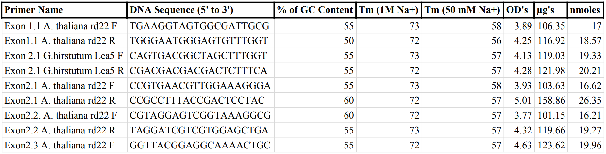
(Fig. 2: showing the information of all primers ordered. All primers were ordered in a dry format
and rehydrated with 100 microliters of water)

1.2. Nanodrop and Spectrophotometry
Since the DNA from the aspen samples had been stored in a freezer for 1 year, the quality of the DNA was verified using a Nanodrop 2000.
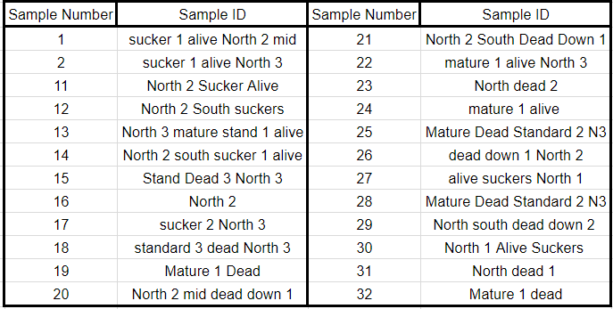
(Figure 3: Sample numbers in order in of purity. The numbering system is referenced in sections regarding PCR)

1.3. Initial Polymerase Chain Reaction
To ensure that the primers ordered fulfilled the needs of the experiment, the 2 samples with the highest 260/230 ratio were selected to run an initial round of PCR, which were Sucker 1 Alive North 2 Mid and Sucker 1 Alive North 3. To start the process of PCR, 2 sets of PCR tubes were laid out and labelled 1-10, 5 of which would be used for Sucker 1 Alive North 2 Mid and another 5 for Sucker 1 Alive North 3. The reagents needed for PCR were gathered, placed in ice, and then pipetted into 10 PCR tubes in the following order and amount: , 2.5 microliters of upstream primer; 2.5 microliters of downstream primer; 12.5 microliters of GoTaq Master Mix; and 5 microliters of water. 2.5 microliters of DNA were also added to PCR tubes so that each primer could react with Sucker 1 Alive North 2 Mid and Sucker 1 Alive North 3. Every PCR tube had 25 microliters of solution before it was moved to the PCR cycler.
The PCR run was composed of 4 steps: initial denaturation, cycles of denaturation, annealing, and elongation, an extension for final elongation, and a hold to prevent Taq from denaturing the DNA again. The initial denaturation lasted 2 minutes at 94° Celsius before moving to the cyclic portion of PCR. The 3-step cycle of denaturation, annealing, and elongation was repeated 30 times. The denaturation step lasted 30 seconds at 94° Celsius, the annealing step lasted 30 seconds at 57° Celsius, and the elongation step lasted 30 seconds at 72° Celsius. After the 30th cycle was a 10-minute hold at 72° Celsius before ending with a 4° Celsius hold.

1.4. Initial Gel Electrophoresis
The PCR samples were run through Electro Gel Phoresis (GEP) with SYBR Green 1 to ensure the primers completed the task of isolating and amplifying the DNA from the aspen samples. The gels were placed in an Electro Gel Phoresis Fotodyne with recycled water with 1X TAE buffer.
2 microliter droplets of SYBR Green and loading dye mix were pipetted onto a segment of parafilm to prepare loading each of the gels. 2 microliters of each PCR sample were mixed with 2 microliters of SYBR Green by pipetting the solution up and down before being loaded into the wells. A ladder was also loaded into each gel. The gels ran at 100 volts for 20 minutes.

1.5. Initial VersaDoc Imaging
After 20 minutes of running GEP, the gels were removed from the TAE and moved to a VersaDoc imaging machine to ensure view the distribution of the DNA and the effectivity of the primers. The camera was set to 5 exposures lasting 2 seconds each.
Exon1.1RD22 reacted in an unsatisfactory manner with both Sucker 1 Alive North 2 Mid and the Sucker 1 Alive North 3, so further use of Exon1.1RD22 in the experiment was discontinued. Therefore, the continuation of the PCR for the rest of the 22 samples would only include reactions with Exon2.1RD22, Exon2.2RD22, Exon2.3RD22, and Exon2.1LEA5.

1.6. Primary PCR
Every sample (except Sucker 1 Alive North 2 Mid and the Sucker 1 Alive North 3) went through PCR using the Initial PCR parameters above with the primer pairs Exon2.2RD22 and Exon2.3RD22. The PCR tubes were labeled with either “2” or “3” depending on the second number of the primer pair used for the reaction and then labeled with the numbers of “11” through “32” depending on the DNA sample used (Fig. 3). This labeling methodology will be referenced in the results.
Electro Gel Phoresis was then run on new samples in a similar methodology. However, the 1X TAE from the previous reaction was not replaced. The gels then ran simultaneously for approximately 20 minutes and sat in the 1X TAE for approximately 1 hour.
The VersaDoc Imaging of the gels used in the Primary PCR was used to validate the efficiency of the primers followed the same parameters as the Initial PCR VersaDoc imaging.

1.7. Secondary PCR, GEP, and VersaDoc Reactions
All of the samples (except Sucker 1 Alive North 2 Mid and the Sucker 1 Alive North 3) went through PCR using the Initial PCR parameters above with the primer pairs Exon2.1RD22 and Exon2.1LEA5 and using the Primary PCR methodology. Exon2.1RD22 corresponded with “1” on the sample tubes, and Exon2.1LEA5 corresponded with “4”.
GEP was run with Primary GEP methodology with the exception of leaving the gels in TAE for only 20 minutes.
VersaDoc Imaging was done following the parameters in the Initial VersaDoc Imaging, but the samples received longer initial and total exposure time to attempt the acquisition of clearer results.

1.8. Tertiary PCR, GEP, and VersaDoc Reactions
To try and verify the primers again, PCR was run with 4 different samples (known as D11, D20, W20, and W18) from a stand nearby to the original 24 samples. The Primary PCR parameters were followed with the following exception: each reagent was halved in order to conserve materials.
GEP for these samples ran in the exact same manner as the Primary reaction, as did the VersaDoc Imaging process.

1.9. Quaternary PCR
Exon2.1RD22, Exon2.2RD22, Exon2.3RD22, and Exon2.1LEA5, from the Initial, Primary, Secondary, and Tertiary PCR, were abandoned for numerous reasons. The original set of primers was replaced with microsatellite primers that were proven to be successful in past experiments on similar samples (such as the ones in the Tertiary reactions). The 2 new microsatellite primers did not have any sequencing information available but will be referred to as O28 and M13. The amounts for the reagents followed in the exact same manner as the Primary PCR, through the Quaternary PCR used all 24 samples (which includes Sucker 1 Alive North 2 Mid and the Sucker 1 Alive North 3).
The cycles used for PCR varied from the other reactions because of the use of different primers. The initial denaturation lasted 2 minutes at 94° Celsius before moving to the cyclic portion of PCR. The denaturation step lasted 30 seconds at 94° Celsius, the annealing step lasted 30 seconds at 51°-57° Celsius, and the elongation step lasted 30 seconds at 72° Celsius. There was a 10 minute hold at 72° Celsius after the 40th cycle, and the reaction ended with a 4° Celsius hold.

1.10. Quaternary GEP and VersaDoc
The parameters for the GEP and VersaDoc followed the same parameters as in the Primary PCR. The VersaDoc imaging process also followed the same parameters with the exception of an initial exposure of 5 seconds and a total exposure of 45 seconds.

RESULTS
4.1. Nanodrop Purity
The spectrophotometry report is listed below in descending levels of 260/230 purity. This does not represent the samples were tested in, but none of the results had any correlation with the order they were tested in, making the inclusion of such data negligible to the experiment.
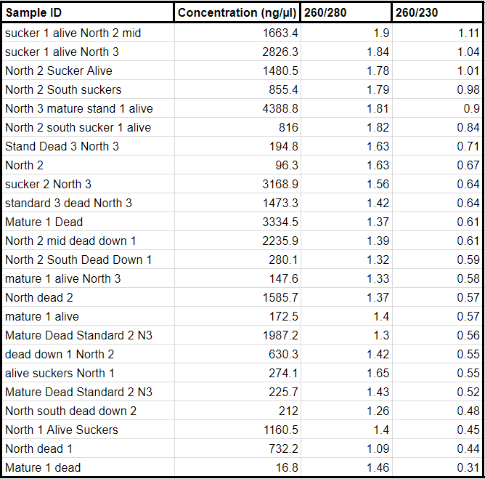
(Fig. 4: Nanodrop cell spectrophotometry results in order of 260/230 purity)

4.2. Gel Electrophoresis and VersaDoc Imaging
Every available image of the results is included. Not every image taken by the VersaDoc Imaging was saved, mostly to due to frustration while viewing the pictures and the lack of foresight to consider saving them. Every reaction is represented by at least one picture.
The color and shade of the photos are not consistent due to the images being saved on the VersaDoc Imaging machine during different states of adjustment. All of the photos included have undergone significant corrections in brightness and contrast for the bands and ladders to observable.
On every photo, there will be an observable ladder with multiple definable segments in the same lane and shorter, rectangular bands representing the solution placed in the wells. Every image is oriented so that the top is the direction the electricity flowed (from negative to positive), or the direction towards which the solution in the wells moved.

4.3. Initial PCR/GEP Results
(Fig. 5: Gel Electrophoresis results from Sucker 1 Alive North 2 Mid. Primer order (left to right): Exon1.1RD22, Exon2.1 RD22, Exon2.2RD22, Exon2.3 RD22, Exon2.1LEA5. Ladder at left; bands exceeded ladder.)
(Fig. 6; Gel Electrophoresis results from Sucker 1 Alive North 3. Primer order (left to right): Exon1.1RD22, Exon2.1 RD22, Exon2.2RD22, Exon2.3 RD22, Exon2.1LEA5. Ladder at right; bands exceeded ladder.)

4.4. Primary PCR/GEP Results
(Fig. 7: Gel Electrophoresis results from PCR samples 211 - 228 (Exon2.2RD22).
Ladders at left; bands exceeded ladders.)
(Fig. 8: Gel Electrophoresis results from PCR samples 311-318 (top) and 229-232 (bottom) (Exon2.3RD22 and Exon2.2RD22). Ladder at right (top) and left (bottom); bands exceeded ladders.)

(Fig 9: Gel Electrophoresis results from PCR samples 319-332 (Exon2.3RD22).
Ladders at right; bands exceeded ladders.)

4.5. Secondary PCR and GEP results
(Fig. 10: Gel Electrophoresis results from PCR samples 111-128 (Exon2.1RD22).
Ladders at left; bands exceeded ladders.)
(Fig. 11: Gel Electrophoresis results from PCR samples 411-418 (top) and 129-132 (bottom) (Exon2.1LEA5 and Exon2.1RD22). Ladders at right (top) and left (bottom); bands exceeded ladders.)

4.6. Tertiary PCR and GEP Results
(Fig. 12: Gel Electrophoresis results from PCR samples of Exon2.2RD22 (top), Exon2.3RD22 (bottom), and Exon2.1LEA5 (middle) for D11, D20, W20, and W18. Ladders at right; bands exceeded ladders.)

4.7. Quaternary PCR and GEP Results
(Fig. 13: Gel Electrophoresis results from PCR samples of M13 11-26. Ladders at right; no bands apparent.)
(Fig. 14: Gel Electrophoresis results from PCR samples M13 27-34 (top) and O28 27-34 (bottom). Ladders at left (top) and right (bottom); no bands apparent.)
(Fig. 15: Gel Electrophoresis results from PCR samples O28 11-26.
Ladders at right (top) and left) bottom; no bands apparent.)

DISCUSSION

5.1. Regarding the NanoDrop results
The results from the Nanodrop 2000 indicated poor DNA purity (Fig. 4). Despite the below average purity levels across all samples, especially in the category of 260/230 purity, the experiment continued for lack of time to properly acquire more samples. If more time was allowed, further samples would have been collected to acquire more recent DNA samples to ensure the stability and viability of the DNA.

5.2. Regarding the Initial, Primary, and Secondary PCR, GEP, and VersaDoc
The results from the Initial PCR, GEP, and VersaDoc Imaging didn’t verify that the Exon2.1RD22, Exon2.2RD22, Exon2.3RD22, and Exon2.1LEA5 (the original set of primers) primers had reacted with the DNA and amplified it in an expected manner (Fig. 5, 6). However, Exon1.1RD22 barely appeared and was discarded from the fear of wasting resources on a faulty primer. The other wells produced a confusing result: the bands were staggered but they all exceeded the ladder, prompting concerns for primer dimer. Primer dimer is a type of PCR failure that occurs when the primers don’t anneal, or attach, to the DNA; therefore, the bands would represent only the primers. In most cases, the primers will anneal to each other because of unsuitable or incorrect conditions (such as incorrect cyclic temperatures for PCR). Primers have a much lower annealing temperature, creating the possibility for them to anneal to each other before the DNA denatures. Some primers have a low enough annealing temperature that even room temperatures will catalyze the reaction, though this would not be the case for the primers used in this study. Primer dimer can also occur when primers have complementary sequences and attach to each other. All primers are designed to have a low molecular weight and would move very quickly through the gel, exceeding the ladder even if they annealed to each other.
In the Primary (Fig. 7, 8, 9) and Secondary GEP (Fig. 10, 11), unsatisfactory imaging was received. The experiment continued after the Primary GEP with the original set of primers in hopes of some an anomalous failed reaction. Bands did appear, which at least validated the existence of primers in the reaction. To the discouragement of such optimism, Exon2.1RD22, Exon2.2RD22, and Exon2.3RD22 appeared faintly and obviously exceeded the ladder, and Exon2.1LEA5 barely appeared. The fact that the bands exceeded the ladder, appeared faintly, and did not have definition lead to the conclusion of complete PCR failure while using the original set of primers with the initial DNA.
The occurrence of PCR failure has multiple causes, but its cause in this experiment could not be determined. A. thaliana and G. hirsutum, the plants used as template sequences for the primers, may have been too genetically different from P. tremuloides. Without correct sequencing information, the primers would not be able to anneal to the DNA samples, creating bands of solely primers that exceeded the ladders. The company that manufactured the primers may have unknowingly created faulty primers that couldn’t anneal the DNA. Primer dimer may also be the cause of the PCR failure, most likely from unsuitable PCR temperatures. Since the bands exceeded the ladder, evidence would support the theory of poorly designed or manufactured primers.
Another type of possible errors causing or contributing the failure of the Primary and Secondary GEP could be traced back to human error. There may have also been unintended oversight pertaining to the protocols during the preparation of or during PCR or GEP, exposing the samples to room temperatures for an abnormal amount of time, pouring the gels ineffectively, or loading the gels poorly. The question of the corruption of the 1X TAE buffer also arose as a possible cause as it was created by someone mixing it for the first time. The buffer would also deteriorate in quality as it was used multiple times.
Lastly, a possible cause for the unwanted results could be the poor quality of the DNA. The DNA may have been isolated faultily, creating a poor product to be studied. Another likely cause is the possible deterioration of DNA. Even though DNA is a stable molecule, it may have degraded after one year, despite its storage in a freezer at -80° Celsius for that time. The results from the Nanodrop 2000 cell spectrophotometry report would support the theory of corrupt DNA because the purity was extremely low.
A pattern to note, however, is that the reactions generally produced worse results as the experiment progressed. This pattern might rule out the possibility of human error as logic would not predict a researcher’s skill to worsen over time, especially as the researcher learned the process of PCR and GEP with no prior knowledge. Progress would be expected as the researcher gained more skill in a previously unknown process. Therefore, the cause of worsening results could be contributed the degradation of an instrument or material in the laboratory after multiple iterations, such as the 1X TAE Buffer, the Fotodyne gel plates, or the environment.

5.3. Regarding the Tertiary PCR, GEP, and VersaDoc
The results from the Tertiary PCR were also disappointing but provided possible insight into the causation of PCR failure (Fig. 12). The results between the Tertiary PCR and the prior three reactions stayed constant: bands exceeding the ladder. Between the two prominent experimental variables (the primers and the DNA), only the primers stayed consant. Therefore, by deduction, the causation of PCR failure could be traced to faulty primers. Without further experimentation, the exact reason for why the primers contributed to the failure cannot be determined. The primers may have incorrect sequencing information, annealed to each other from unsuitable thermal cycler conditions, or may have been poorly manufactured.

5.4. Regarding the Quaternary PCR, GEP, and VersaDoc
The nearly total lack of results from a different primer pair was perplexing (Fig. 13, 14, 15) . In the Primary, Secondary, and Tertiary reactions, poor results were observed (Fig. 5-12), but in the Quaternary reactions, there was only the lack of results to observe. The lack of results caused us to partially disregard the theory of the initial primers causing the failure because the O28 and M13 microsatellite primers also produced inconclusive results.
The first possible cause could be the deterioration of the DNA at the specific bonding locations for the primers. If the entire DNA was corrupt, then all the PCR reactions should have produced results similar to the Quaternary reactions. Instead, the corrupted sequences may only be for the portions at which the primers would anneal. Another possible cause would be the poor design of the microsatellite primers, though poorly designed primers should have produced similar results to the first four reactions: bands that exceeded the ladder. However, the microsatellites may have been manufactured differently and produce PCR failure in a manner unlike the original primers.
5.5. Sequencing
Since the PCR reactions created samples unsuitable for sequencing and there was a severe shortage of time to continue, no sequencing analyses were conducted in this study. With apt PCR samples and enough time, the acquisition of sequencing information would be greatly sought after. From the sequencing information, comparisons between the LEA5 and RD22 genes of dead and living aspens could be collected and analyzed.
Since no samples were sequenced, the results of this study are inconclusive. The PCR failures produced in this experiment are either from DNA deterioration or primer faults. Without more time, the exact cause cannot be narrowed down. If more time were allowed, it would be invested in collecting new samples and creating new primers instead of attempting to find the causations of failure in this study.
We would predict that a mutation would in the LEA5 and RD22 genes would be present in the aspens fatally affected by Sudden Aspen Decline. A neutrally selected adaptation may have also been present in the alive aspens that allowed them to combat drought with a greater efficiency. However, because only seventeen percent (a minority) of aspens were affected, we believe that a random mutation occurred in the dead aspens that was only expressed with the presence of drought. We would also predict that the populations between the live and dead aspens would be similar, indicating that the mutation occurred relatively recently (Freeland, J. R., Kirk, H., & Peterson, S. D., 2013). If the populations were dissimilar, then the mutation would have occurred at some point in the far past. Dry, warm, and long droughts would have occurred before 2002, meaning the lineage carrying the mutation would have been killed off.

CONCLUSION
Despite all of the setbacks, this experiment and the results provided a chance to think about Sudden Aspen Decline in a new light: genetically. Sudden Aspen Decline, the rapid and genet-isolated deterioration of aspens, could now have a cause greater than fungus, beetles and drought. The propensity to mutate, which can act as a strong method of non-selective adaption, started the decline. Only a few basepairs of DNA may have mutated, but that few basepair difference caused seventeen percent decline in a hardy, pioneer species. If only a few basepairs can cause one in five trees to die, a few basepair differences could make a species flourish. A possible cause to the problem has been identified, and all that remains is the solution.
The issue may lie in the genes that we didn’t have to opportunity to study in depth: RD22 and LEA5. If more time was allowed, a stronger pursuit of these genes would be highly encouraged. If SAD has such a large correlation to drought, then more research into the drought resistance genes of aspens would be a tremendous start into solving the problem. The real goal would be collection all of the possible alleles of aspens or fully genoming the Populus taxa, though that may be unattainable in the near future. SAD may provide us with the gateway into researching the relations between different resistances in aspens, such as the relatedness of drought resistance to freezing resistance, and the relatedness of these genes when compared to different environmental factors. Does an inverse relationship exist between two opposing resistances (such as drought and freezing) in a species that has a capability of adaptation, or do all possible alleles exist and are only used when called upon by the environment? Research in this area would have enormous overlap with epigenetics, another field to consider when studying massive clonal organisms. Another possible area of study is the behavior of suckers in aspens. This could include how they proliferate throughout an environment, including the development of proteins in early stages. To think with a visionary perspective, the true goal would be to create a fully sustainable cloning species adaptable to multiple environments. If Populus tremuloides were sustainable on another planet (Astrobiology; Seager, S., Turner, E., Schafer, J., & Ford, E., 2005), then it would be only a matter of time until the whole Red Planet turned green.
In conclusion, while the experiment didn’t go as planned, there was still much to learn from the failed reactions and the experience. More experimentation, exploration, and discovery is always encouraged, especially in a field that makes Earth such a unique planet. While Earth may be struggling, there are still frontiers to find and plants to grow there. We may not have produced groundbreaking results, but we did produce a simple reminder: in the same way small changes can cause great decline, small changes can cause a species to flourish.

ACKNOWLEDGEMENTS
I thank the following people for everything they have invested in me, poured into me, and taught me. I specifically thank Xcel Energy for being my research sponsor, even though my experiment didn’t go as planned; Amie Bray for being my research mentor, communicating with me, and allowing me to communicate with her; Dr. McGlaughlin for letting take part in his research; Viva Rasè for mentoring me throughout my research, answering my numerous questions, giving me an opportunity to experience Biology lab research, and giving me a new outlook on life; Zoë Zizzio and Akshitha Mudupu for helping me run PCR and giving me encouragement when my experiment seemed hopeless; Jaden Hutchins and Michael Winchester for looking over my paper, encouraging me, and making sure I survived in the dorm; Lori K. Ball for directing and coordinating the 2018 Frontiers of Science Institute and doing it for years to come; Rogene Lowe and Jane Radford for pushing me and giving me the confidence needed to attend FSI, and preparing me throughout school past solely academics; and my fantastic family for keeping in touch, encouraging, listening, and staying with me throughout this journey, as well as funding my attendance to this amazing camp. For everyone who interacted with me, helped me, and became a long-lasting friend, I thank them as well.
References:
Becheler, R. (2014). The concept of population in clonal organisms: Mosaics of temporally colonized patches are forming highly diverse meadows of Zostera marina in Brittany. Molecular Ecology,23(11), 2886-2886. doi:10.1111/mec.12787
Bresinsky, A., Körner, C., Kadereit, J. W., Neuhaus, G., & Sonnewald, U. (2013). Strasburger's Plant Sciences(36th ed.). Berlin, Heidelberg: Springer. doi:https://doi.org/10.1007/978-3-642-15518-5
Cook, R. E. (1983). Clonal Plant Populations: A knowledge of clonal structure can affect the interpretation of data in a broad range of ecological and evolutionary studies. American Scientist,71(3), 244-253. Retrieved July 12, 2018, from https://www.jstor.org/stable/27852011.
Dewoody, J., Rowe, C. A., Hipkins, V. D., & Mock, K. E. (2008). “Pando” Lives: Molecular Genetic Evidence of a Giant Aspen Clone in Central Utah. Western North American Naturalist,68(4), 493-497. doi:10.3398/1527-0904-68.4.493
Freeland, J. R., Kirk, H., & Peterson, S. D. (2013). Molecular Ecology (2nd ed.). West Sussex, UK: Wiley-Blackwell.
Howard, J. L. (1996). Populus tremuloides. Fire Effects Information System [Online]. Retrieved July 1, 2018, from https://www.fs.fed.us/database/feis/plants/tree/poptre/all.html
Korb, J., Bombaci, S., & Siegel, R. (2014). The effect of sudden aspen decline on understory microclimate and vegetation in southwestern Colorado. Canadian Journal of Forest Research,44(8), 914-921. doi:10.1139/cjfr-2014-0087
Kroeger, J. H., Zerzour, R., & Geitmann, A. (2011). Regulator or Driving Force? The Role of Turgor Pressure in Oscillatory Plant Cell Growth. PLoS ONE,6(4). doi:10.1371/journal.pone.0018549
Lan, T., Gao, J., & Zeng, Q. (2012). Genome-wide analysis of the LEA (late embryogenesis abundant) protein gene family in Populus trichocarpa. Tree Genetics & Genomes,9(1), 253-264. doi:10.1007/s11295-012-0551-2
Mitton, J. B., & Grant, M. C. (1980). Observations on the Ecology and Evolution of Quaking Aspen, Populus tremuloides, in the Colorado Front Range. American Journal of Botany,67(2), 202. doi:10.2307/2442643
NOAA National Centers for Environmental Information. State of the Climate: Drought for Annual 2013. United States of America Department of Commerce. (2014, January 15). Retrieved July 1, 2018, from https://www.ncdc.noaa.gov/sotc/drought/201313
Orio, A. P., Callas, R., & Schaefer, R. J. (2005). Forty-eight year decline and fragmentation of aspen (Populus tremuloides) in the South Warner Mountains of California [Abstract]. Forest Ecology and Management,206(1-3), 307-313. doi:10.1016/j.foreco.2004.11.011

Possen, B. J., Oksanen, E., Rousi, M., Ruhanen, H., Ahonen, V., Tervahauta, A., . . . Vapaavuori, E. (2011). Adaptability of birch (Betula pendula Roth) and aspen (Populus tremula L.) genotypes to different soil moisture conditions. Forest Ecology and Management,262(8), 1387-1399. doi:10.1016/j.foreco.2011.06.035
Romme, W. H., Turner, M. G., Wallace, L. L., & Walker, J. S. (1995). Aspen, Elk, and Fire in Northern Yellowstone Park. Ecology,76(7), 2097-2106. doi:10.2307/1941684
Seager, S., Turner, E., Schafer, J., & Ford, E. (2005). Vegetations Red Edge: A Possible Spectroscopic Biosignature of Extraterrestrial Plants [Abstract]. Astrobiology,5(3), 372-390. doi:10.1089/ast.2005.5.372
Worrall, J. J., Egeland, L., Eager, T., Mask, R. A., Johnson, E. W., Kemp, P. A., & Shepperd, W. D. (2008). Rapid mortality of Populus tremuloides in southwestern Colorado, USA. Forest Ecology and Management,255(3-4), 686-696. doi:10.1016/j.foreco.2007.09.071
Worrall, J. J., Keck, A. G., & Marchetti, S. B. (2015). Populus tremuloides stands continue to deteriorate after drought-incited sudden aspen decline. Canadian Journal of Forest Research,45(12), 1768-1774. doi:10.1139/cjfr-2015-0225
Worrall, J. J., Marchetti, S. B., Egeland, L., Mask, R. A., Eager, T., & Howell, B. (2010). Effects and etiology of sudden aspen decline in southwestern Colorado, USA. Forest Ecology and Management,260(5), 638-648. doi:10.1016/j.foreco.2010.05.020

Yamaguchishinozaki, K., & Shinozaki, K. (1998). The Plant Hormone Abscisic-Acid Mediates the Drought-Induced Expression but not the Seed-Specific Expression of RD22, a Gene Responsive To Dehydration Stress In Arabidopsis-Thaliana. Molecular and General Genetics,238(1-2), 17-25. Retrieved July 1, 2018, from http://apps.webofknowledge.com/InboundService.do?customersID=ProQuest&mode=FullRecord&IsProductCode=Yes&product=WOS&Init=Yes&Func=Frame&DestFail=http://www.webofknowledge.com&action=retrieve&SrcApp=Summon&SrcAuth=ProQuest&SID=7BWofz8bSipcWFlGXeN&UT=WOS:A1993KY63000003

